DNS configuration



Webforwarder to 37.148.162.5:8081

Stunnel config file

[https]
accept = 37.148.162.5:8081
connect = 37.148.162.5:8247
cert = coacheducationrestyled.be2018.pfx

Accepting on 37.148.162.5:8081
Connecting to 37.148.162.5:8247

EWB webserverconfiguration
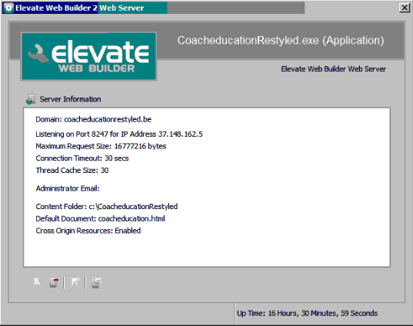

Webserver listening on 37.148.162.5:8247

Start Stunnel



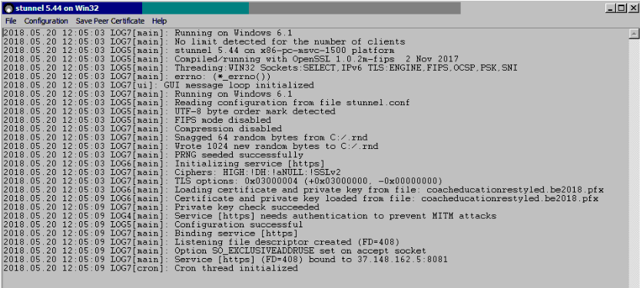

When starting Stunnel the certificate is loaded without errors and the private key check succeeded

Service [https] is bound to 37.148.162.5:8081

SO LOGICALLY SPOKEN THE CONFIGURATION LOOKS OK !!

When I open a browser and want to start www.coacheducation.restyled.be

The connecyion does not succeed and I see the following info in the log window:

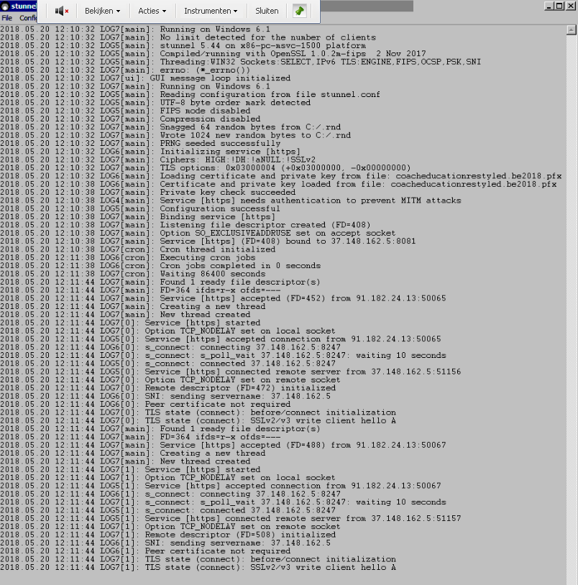

What can be the problem here.

And the weirdest thing is that I managed to make a few secured connections ( so this configuration did wordk) and all of a sudden this doen not work anymore.

! I need help !!!!

